**周亚男 2020131062**

## 完善合约代码

004_Vote.sol

// SPDX-License-Identifier: GPL-3.0

pragma solidity ^0.8.0;

import "@openzeppelin/contracts/access/Ownable.sol";

contract Poll is Ownable {

    // 代表总的提案数

    uint8 public candidates;

    // 代表总的投票人数；

    uint public turnout;

    // 代表投票持续的秒数。

    uint public duration;

    // 记录了这一轮投票结束的时间戳

    uint public endTime;

    // 别标记目前投票是否已经开始/结束

    bool public started;

    bool public ended;

    // 表示已经投票人数。

    uint public votedNum;

    // 跟踪目前得票最高的候选人索引。

    uint8 public highestCandidate;

    // 最高候选得的票数

    uint public highestScore;

    // 存储了每个投票人针对各个提案做出选择的记录。

    mapping(address => uint8) public votedMap;

    // 存储了每个提案目前的总得票数。

    mapping(uint8 => uint) scoreMap;

    event Started();

    event Ended();

    constructor(uint8 _candidates, uint _turnout, uint _duration) {

        candidates = _candidates;

        turnout = _turnout;

        duration = _duration;

    }

    function start() external onlyOwner {

        require(!started, "poll is over");

        require(candidates > 0, "invalid num");

        require(turnout > 0, "invalid num");

        endTime = block.timestamp + duration;

        started = true;

        emit Started();

    }

    function end() public {

        require(started, "poll not start");

        require(!ended, "poll is over");

        require(endTime <= block.timestamp, "time not arrive");

        ended = true;

        emit Ended();

    }

    function _end() internal {

        require(started, "poll not start");

        require(!ended, "poll is over");

        ended = true;

        emit Ended();

    }

    function vote(uint8 candidateIndex) external {

        require(started, "poll not start");

        // require(!ended, "poll is over");

        require(block.timestamp < endTime, "time invalid");

        require(votedNum <= turnout);

        require(

            candidateIndex > 0 && candidateIndex <= candidates,

            "invalid num"

        );

        require(votedMap[msg.sender] == 0, "u have already polled");

        votedMap[msg.sender] = candidateIndex;

        scoreMap[candidateIndex]++;

        votedNum++;

        if (scoreMap[candidateIndex] > highestScore) {

            highestCandidate = candidateIndex;

            highestScore = scoreMap[candidateIndex];

        }

        //自动触发

        if (votedNum == turnout) {

            _end();

        }

    }

    function getResult() external view returns (uint8) {

        require(ended);

        return highestCandidate;

    }

}

## 实验过程

1. 部署  
   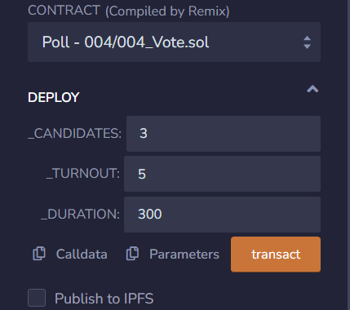
2. 调用start  
   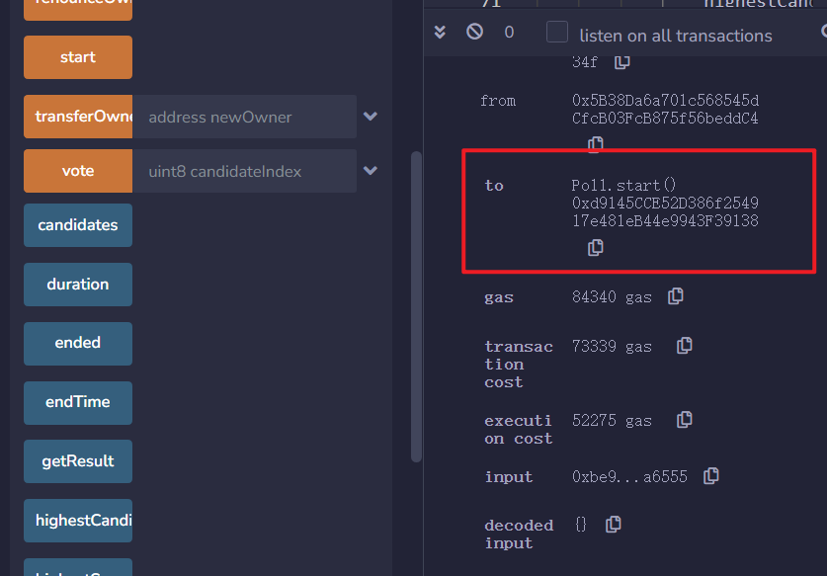
3. 使用 5 个账户，分别对 3 个提案进行投票；比如第一提案获得了最高票 3 票，  
   